ASSIGNMENT 7
Add a new column ‘Email’ in the sheet. Populate this ‘Email’ (for every row) using appropriate excel formulas to generate Email Ids as combination of ‘EmployeeFirstName_EmployeeLastName@CompanyName.ac.in’
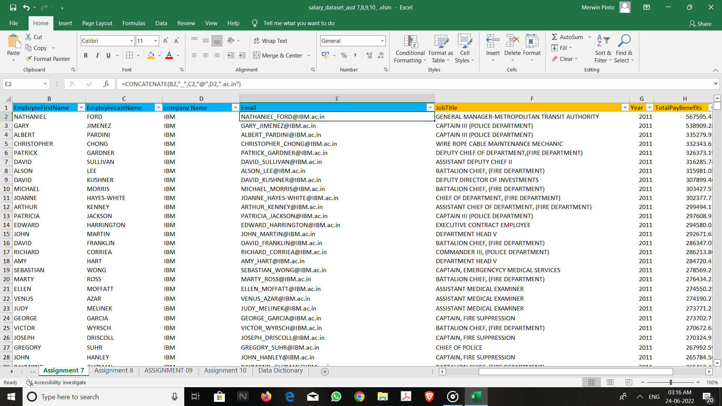
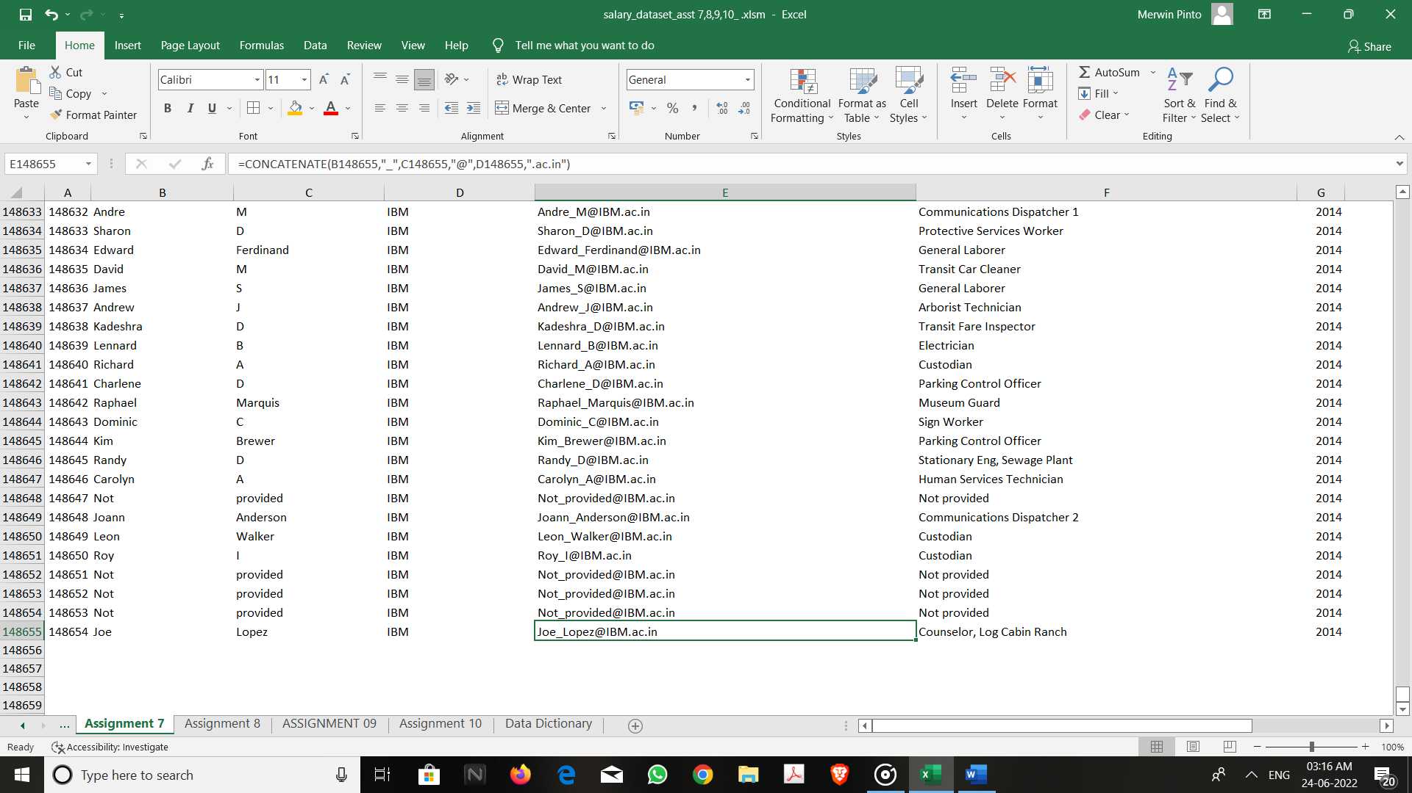

ASSIGNMENT 8
Use appropriate excel formulas to 1. Count the number of employees by the joining year (the year employee joined the company) 2. Count the number of employees by their job title
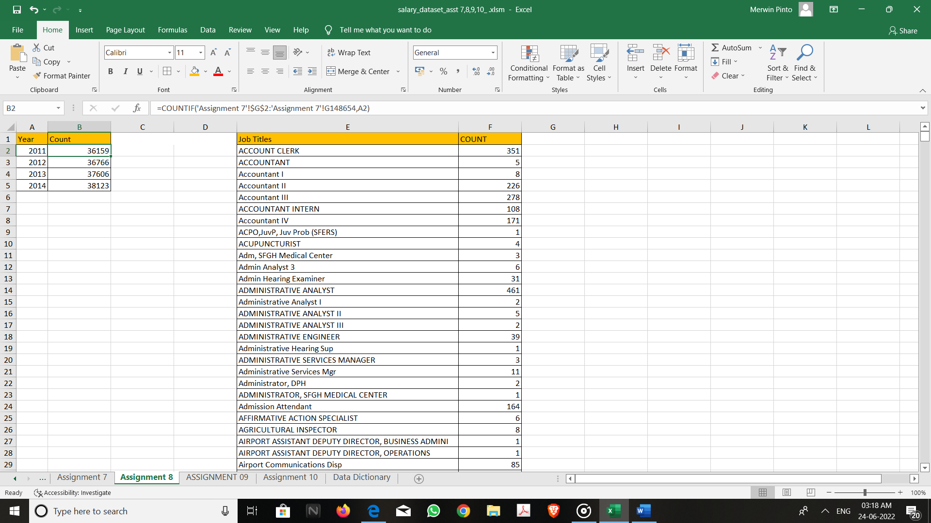
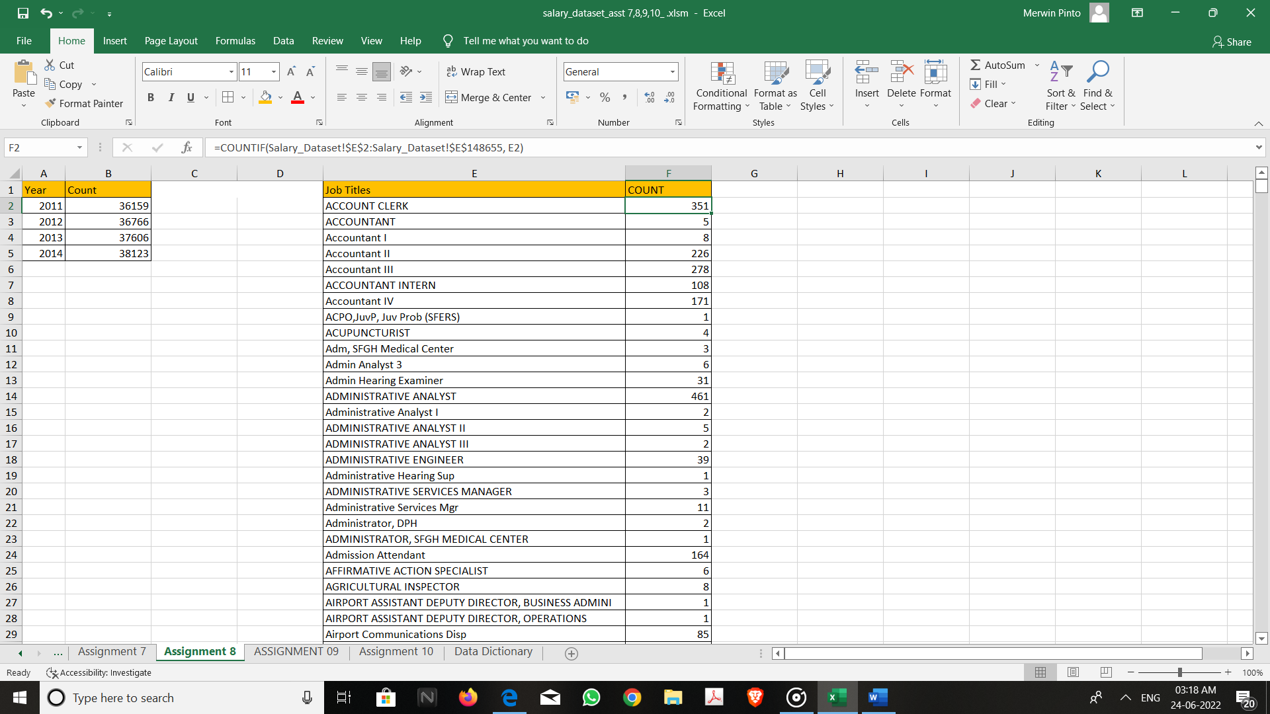
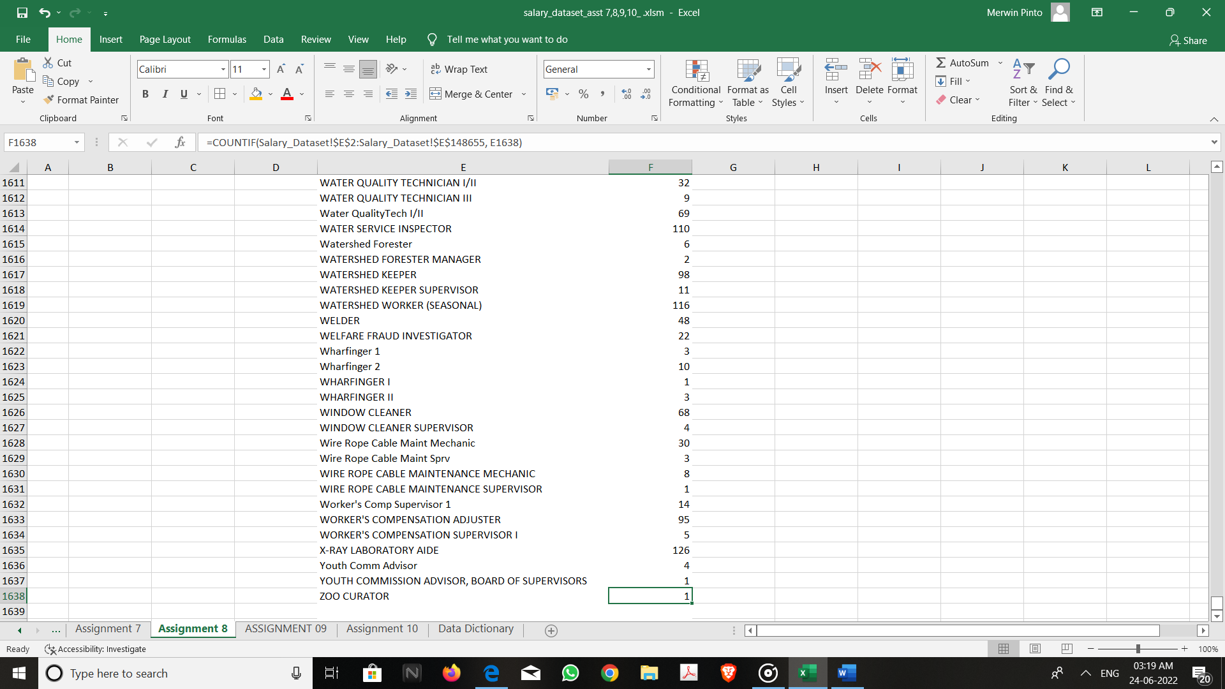

ASSIGNMENT 9
Plot a graph for below scenarios: 1. Count of employees by year in a bar chart 2. Average Total Pay Benefit by Year in a bar chart
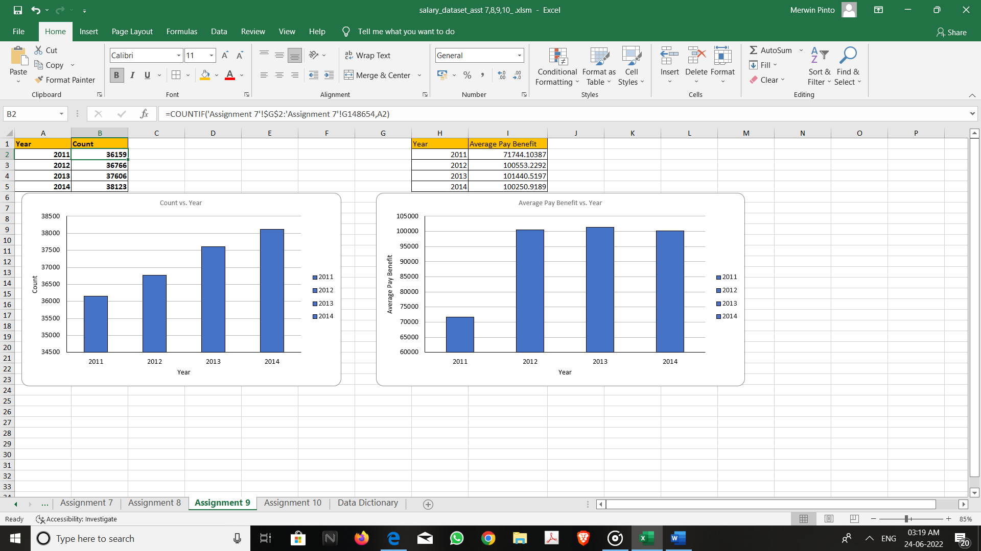
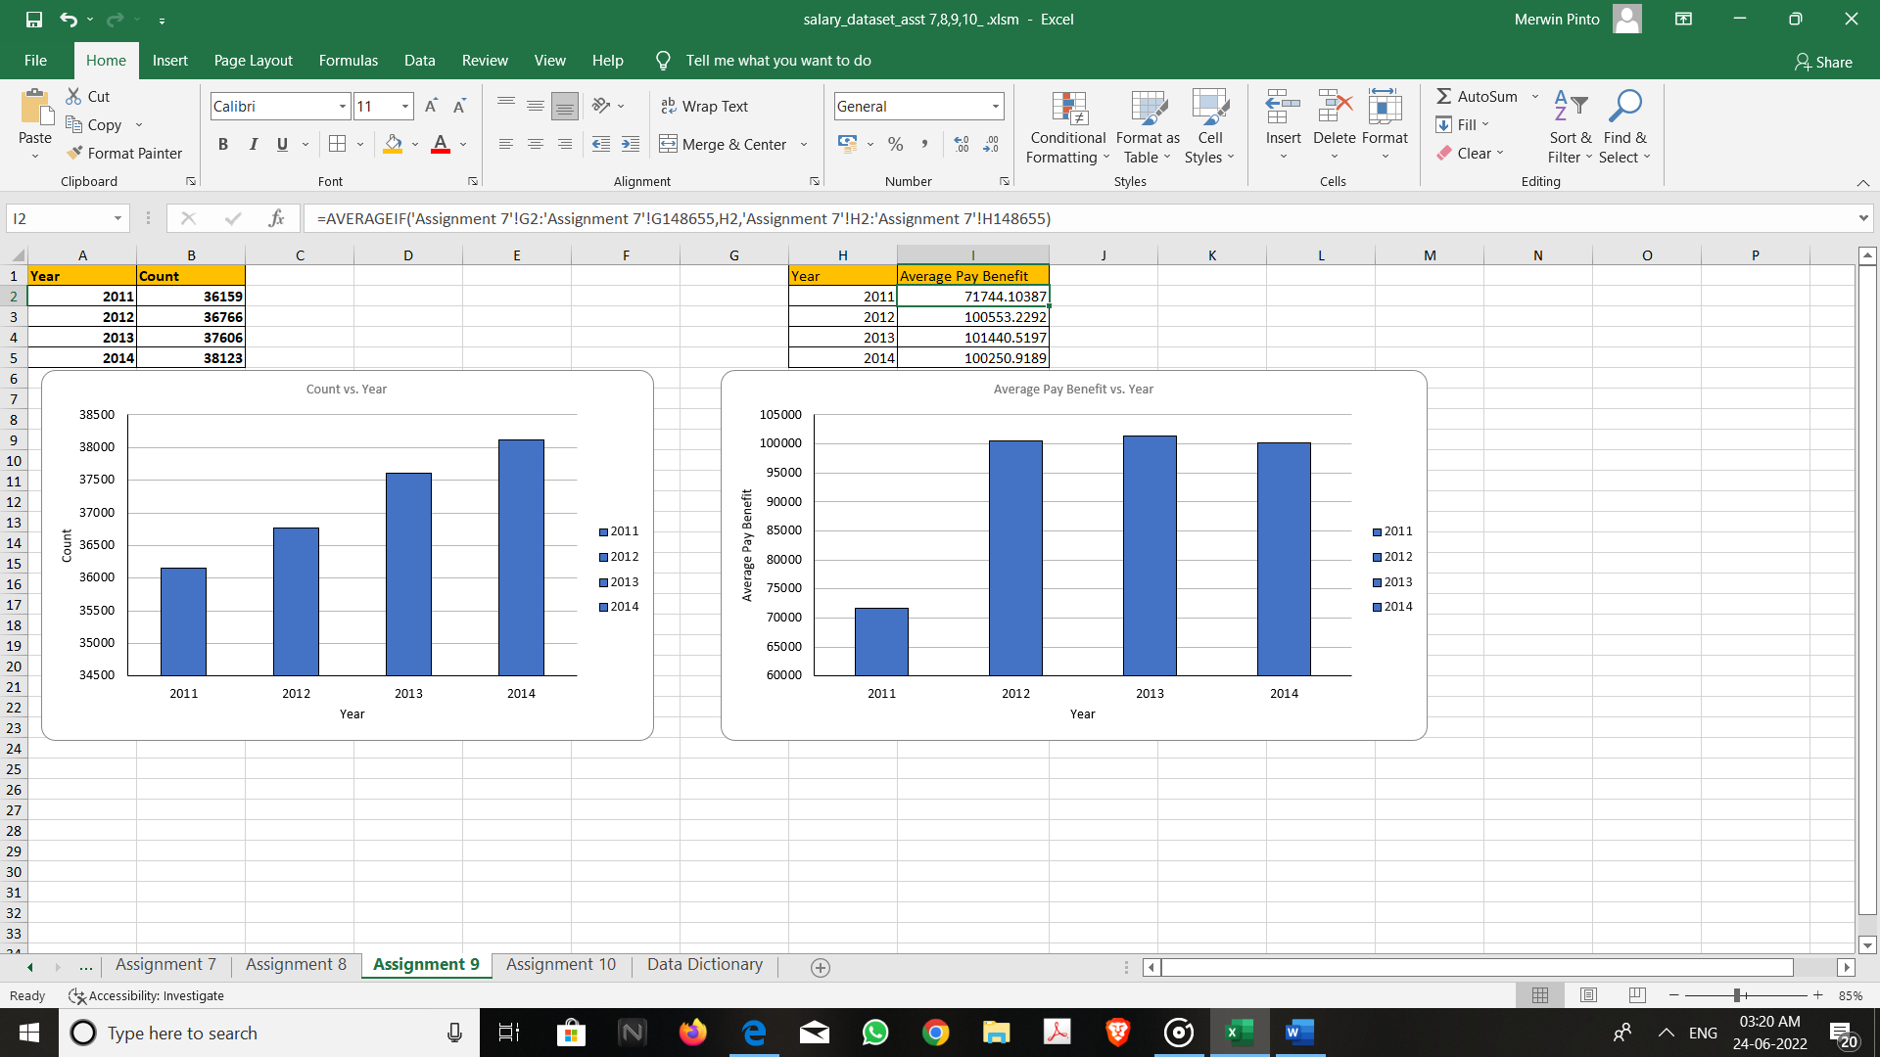

ASSIGNMENT 10
Calculate the Summary Statistics for below: 1. Mean, Median, Min and Max for Total Pay Benefit
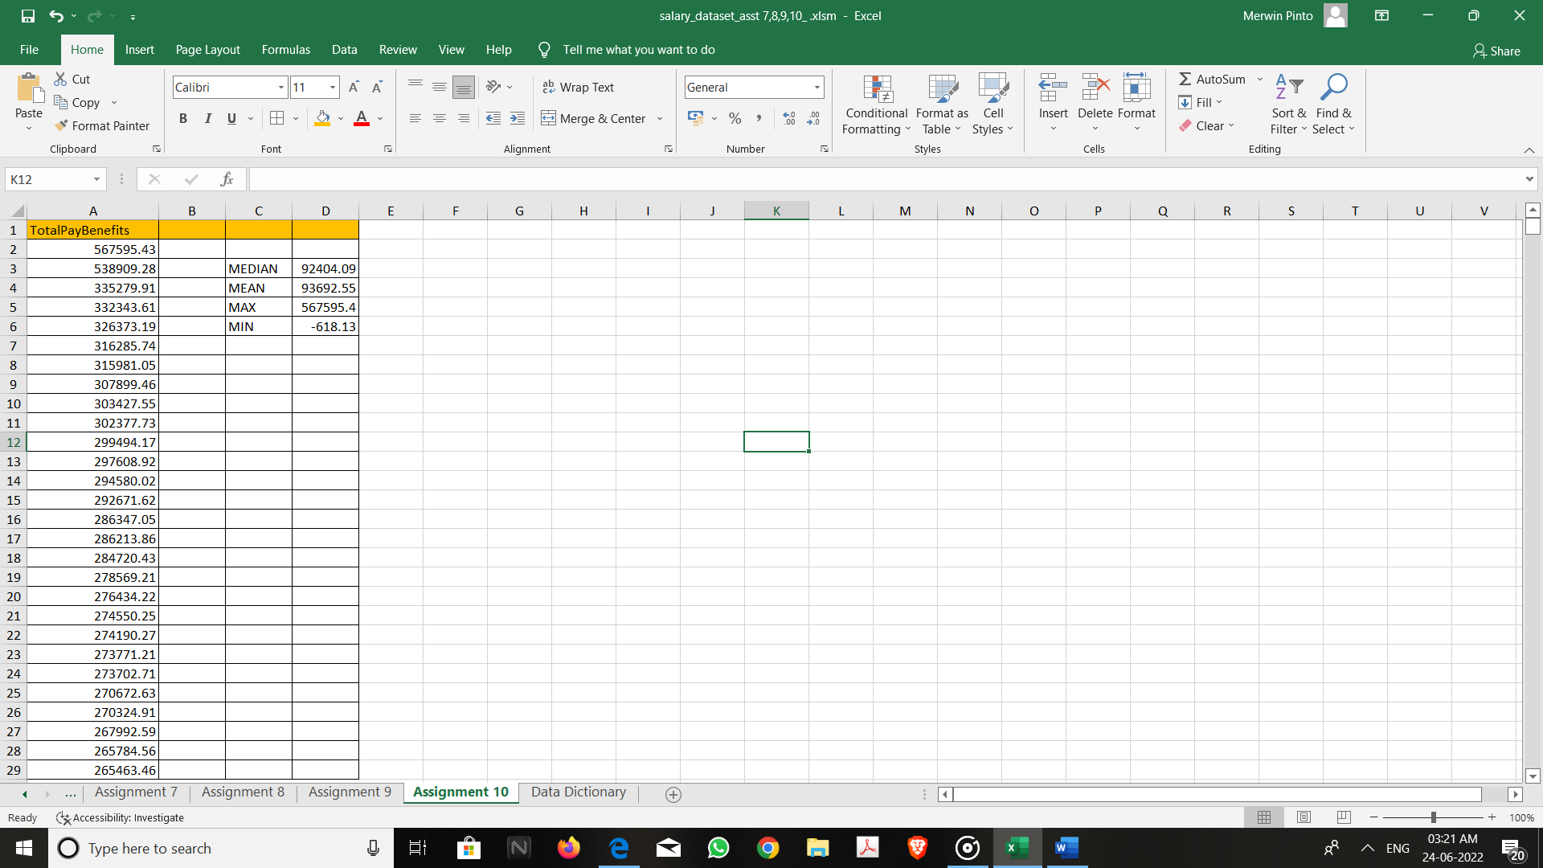
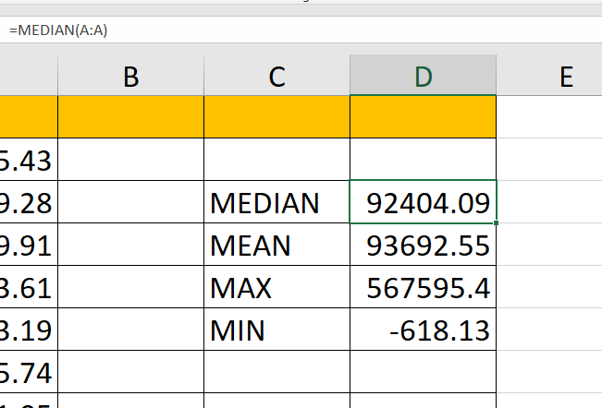

FORMULAS USED are :
=MEDIAN(A:A)
=MEAN(A:A)
=MAX(A:A)
=MINA:A)

